About Discovery Harbour
A naval and military past
Discovery Harbour traces its roots back to the original British naval and military base in Penetanguishene, built to safeguard access to Upper Canada after the War of 1812. "His Majesty's Naval Establishment on Lake Huron", (as it was first called) kept ships prepared to supply British posts to the northwest. By 1820, it was home to over 70 people, including sailors, officers, shipwrights, and soldiers. Five large ships, 15 smaller vessels, and numerous workshops and dwellings were built.
In 1828, a British garrison on Drummond Island was relocated to Penetanguishene. By 1834, Canada was defended exclusively by these forces. An impressive stone Officers' Quarters was built in 1845. The military occupied the site until 1856.

- Historic Naval and Military Establishments
FORMER DESIGNATION, CORRECT, ONTARIO

OBS
Discovery Harbour, on scenic Penetanguishene Bay, will take you back in time to the presence of British naval and military forces in Central Ontario. Come and explore this recreated, 19th century community on the southeast corner of Georgian Bay. An Ontario tourism destination, Discovery Harbour is also home to the replica British sailing ships H.M.S. Tecumseth and H.M.S. Bee. Tour the historic properties, including the restoration project on the Officers' Quarters, and learn first-hand the challenges of shipwrights, sailors, soldiers and other military and civilian personnel at this isolated outpost built to defend Upper Canada.
The naval and military establishments in Penetanguishene operated for 39 years, from 1817 to 1856. In the summer of 1951, the Chamber of Commerce of Penetanguishene decided to develop the site of the old establishment as an historical and recreation park. It restored the remaining buildings, the officer's quarters, and opened a scenic road along the bay. It was called the Historic Naval and Military Establishments. Its name has been changed just recently to Discovery Harbour and it is a picturesque scene covered with old buildings and horse drawn carriages.
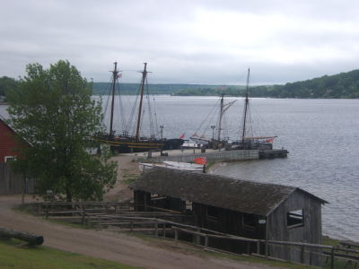
Discovery Harbour, showing replicas of HMS Tecumseth,
HMS Bee, and the sawpit in foreground.
Photo by J. Gray
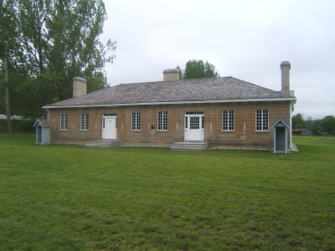
In 1793, Upper Canada's first Lieutenant-Governor, John Graves Simcoe, recognized the young colony's vulnerability to attack and set about establishing a plan for its development and protection. As part of an overall defence strategy, the harbour at Penetanguishene seemed an ideal location for a naval establishment. The long, steep-sided water of Penetanguishene Bay was well suited for the maintenance of ships, and the base would be strategically tucked around the entrance to Georgian Bay and Lake Huron. Arrangements were made in 1795 to purchase the land from the Ojibway.
Penetanguishene's strategice importance as a "back door" safeguard to Upper Canada was confirmed during the War of 1812. The need to secure supply lines to bases in the northwest and protect shipments of gifts to Britain's native allies was high. Plans were drawn up for the construction of a 36-gun frigate which would assure British naval superiority on the Upper Lakes. But the proposed developments were delayed and the frigate was never built- in 1814, the Treaty of Ghent officially ended hostilities between Britain and America, and the expense of building at Penetanguishene caused the stoppage of all work at the outpost.
By 1817, construction of the Penetanguishene base finally became a priority. There was a need to have a strong naval force on Lake Huron should hostilities renew with the United States. The Rush-Bagot agreement between Britain and the U.S. placed restrictions on the number of active warships each side could have on the Great Lakes. As a result, two British warships, Tecumseth and Newash, required a harbour where they could be decomissioned and maintained in a state of "Ordinary" i.e., where their hulls could be moored and their guns, sails and rigging could be stored and kept in a state of readiness. The Penetanguishene location could accomodate this, and Tecumseth and Newash were deployed there in June of 1817. The focus of the Naval Establishment was to now maintain these vessels as well as other smaller craft, and to be the major supply depot on Lake Huron. By 1820, the base was home to more than 70 personnel, including sailors, civilian workers, officers, and a military (army) guard. Although the Penetanguishene Naval Establishment was at this time a naval operation, the presence of soldiers was not unusual. In additon to safeguarding the stores and supplies, they provided assistance in stopping unruly behaviour among the men at the base. They also formed a useful work party, assisting in much of the labour required at a frontier outpost.

Officer's Quarters, Discovery Harbour,
Photo by Jason Gray
The continuing peace with the Americans and further financial pressures back in England took their toll on the military prsence in the Canadian colonies. The gradual withdrawl of British troops meant that alternate methods of manning frontier posts were required, and from 1846-51, this role was filled by the Royal Canadian Rifle Regiment. By 1851, even this expense could not be maintained, and the garrison at Penetanguishene was left to the care of a number of pensioners. In 1856, the base was closed down entirely- another era had come to an end.
Following its closure, the Military Establishment's lands and remaining buildings were turned over to the Canadian government. In 1859, they were given new purpose as a juvenile reformatory for boys, where youths were sent to undergo a program of discipline and responsibility. The former Officers Quarters served as the warden's residence, and the Soldiers Barracks were converted into the inmates' dormitory. Former Adjutant James Keating's home housed the facility's chaplain and newer structures and workshops were built on the surrounding hillside. The gradual elimination of the reformatory system at the turn of the 20th Century paved the way for yet another era. In 1904, the entire complex was given over as the Hospital for the Insane, which eventually developed into the modern mental health complex, now standing on the hillside above the historic properties. For many years, the Officer's Quarters became a private residence for families associated with the hospital.

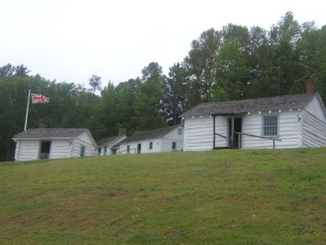
Quartermaster and Clerk's offices (front) with the
sailor's barracks behind.
Photo by J. Gray
In 1953, Dr. Wilfred Jury, from the University of Western Ontario, raised the original hull of the warship HMS Tecumseth from the bottom of Penetanguishene Bay. Dr. Jury later began a series of excavations on the historic properties and oversaw the site's reconstruction. During this period, the Officers Quarters underwent restoration and served as a museum dedicated to the history of the original Naval and Military Establishments. In 1973, the reconstructed Naval and Military Establishments first opened as a living history site, and has continued to offer a vareity of heritage experiences to visitors. Further developments between 1991 and 1994 included the King's Wharf Theatre, waterside boardwalks, a restaurant, and a gift shop.
While no original structurs remain from the original Naval Establishment, it has been reconstructed according to the historic blueprints and an attempt has been made to preserve the proper arrangment of buildings. Discovery Harbour represents the peak period of activity from 1817 to 1822. Among the historic buildings visitors can experience are a naval storehouse, a dockyard which consists of a sawpit, steam kiln and blacksmith shop, offices of the quartermaster and clerk-in-charge (a civilian position), the sailors barracks, officer's quarters and houses belonging to the commanding officer, the surgeon, the naval surveyor and the fort adjutant. The soldiers, along with many of their wives and children, were housed in a stone barracks near the officer's quarters.
Discovery Harbour is open seasonally, offering both self-guided and guided tours by staff in period costume. In addition to the structures, visitors can also board and tour the two ships anchored at the King's Wharf, as well as enjoy an audio visual presentation in the North Visitors Center. The hull of the original warship HMS Tecumseth is also on display here. For more information, visit their website.

